

Survey Site

COMP1011 – Advanced Web Programming

Scott Montgomery and Nolan Knill

Friday, April 19, 2013

Table of Contents

Site Description 3

Wireframes 5

Screenshots 7

Future Functionality 14

# Site Description

Survey Site is a survey site where a user can register to create surveys to be taken by anonymous users, and their friends. Once registered, the user can manage their surveys, edit their profile, view survey results, and share their surveys on Facebook or through e-mail.

When a user registers for the site, they are required to enter their name, email address and password. Upon validating the registration information, the user is created in the database and the user is able to log into the website.

After the user successfully logs into the site, the corresponding session variable relating to login is set. This provides the site which an easy ability to identify which user is logged into the system.

Once the user is logged into the site, they have the ability to create a survey. The initial create survey page will ask the user to provide the name of the survey, the start date, the end date, type of survey they will be creating (ie multiple choice, agree or disagree) and the number of questions that the survey will have. After validating all of this information (including if the start date is not later than the end date is), the user is then directed to the add questions page. This is the page where the user is prompted to type out the questions and answers for each of the questions in the survey. If the survey type is agree or disagree then the user is only prompted to enter the questions, since the answers will always be either agree or disagree.

After the user has created has created a survey they will be able to view the my_surveys page which lists all of the surveys they have created. From this page they will be able to access a variety of other pages of the site including: take survey, edit survey, share survey and show the details of a survey.

When a user goes to the page to take a survey, the site checks if the survey is active (now is within the start date and the end date) and if it is, displays each of the corresponding questions and their answers. Each answer has a corresponding radio button that when selected signifies that this is the answer the user wishes to use for that question. Upon submitting the form the page is validate to ensure that all of the questions have been answer. The results of the user’s submission are then saved to the database.

The edit survey page allows the user to change the name of a survey, the start date and end date. Because a survey may already have questions associated with it, at this point in time the system does not provide the functionality to change the number of questions associated with a survey or the type of survey. However this may be implemented in a future version.

The email survey page is a page with a form on it that allows the user to specify an email address and the body of an email to send to someone to ask them to complete the specified survey. This message is fully customizable. After the form is submitted and validated, the email is sent through the use of the php mail function. In addition to being able to share a survey via email, a user of the site is also provided with the ability to share a survey via facebook.

The details page shows: the start and end date of a survey, the total number of submissions and the survey type. Below the details of the survey, each of the questions is listed with the corresponding answers. For each answer the number of people that have chosen that answer is displayed.

Upon logging out of the system, the user session is destroyed and the user is returned to the login page.

If a user is not logged into the system, they are still able to take surveys and submit them but unable to view any of the details associated with a survey. There is a sidebar that appears on all pages of the site that provides the user with a link to take a survey that is randomly selected from the database.

# Wireframes

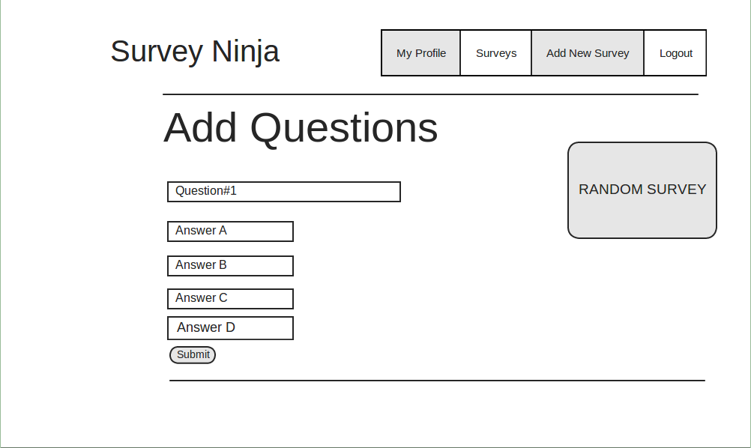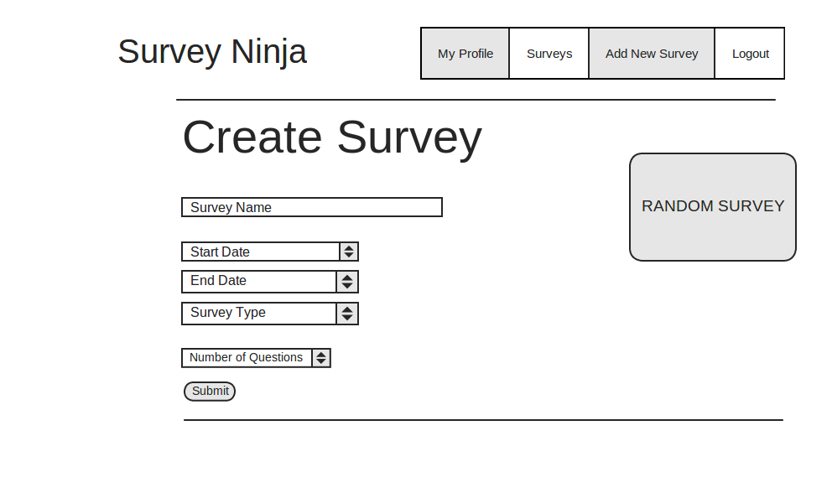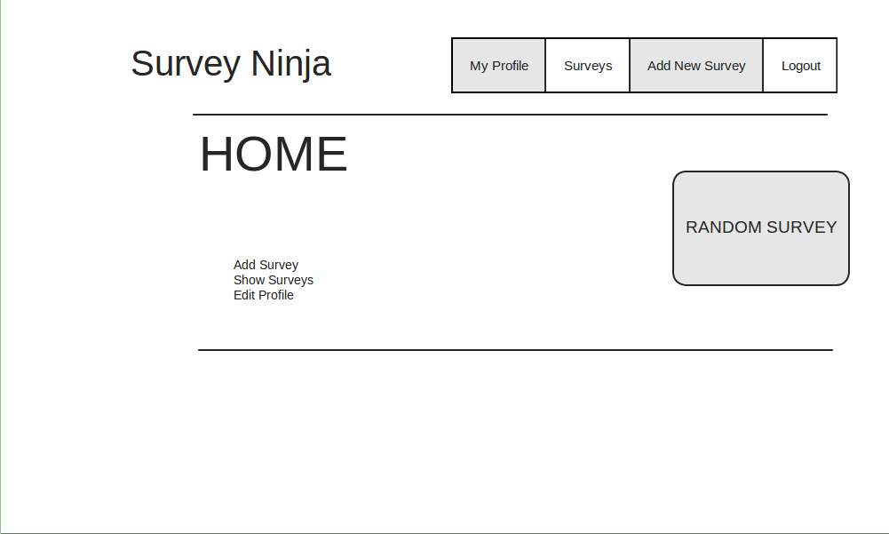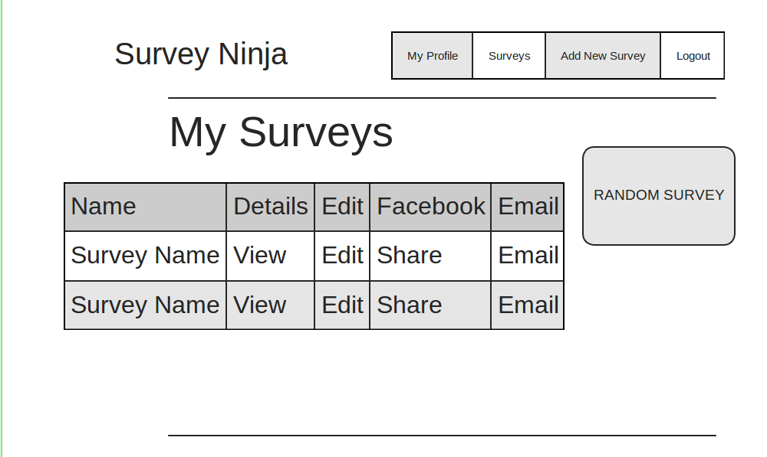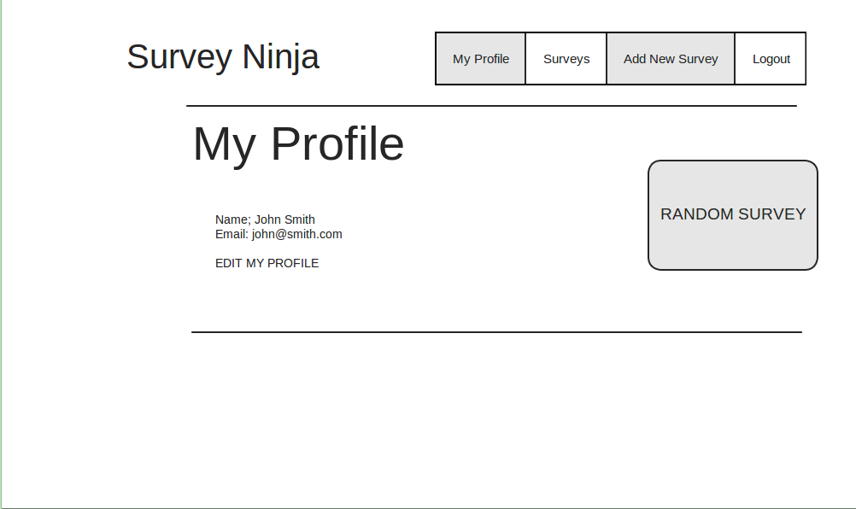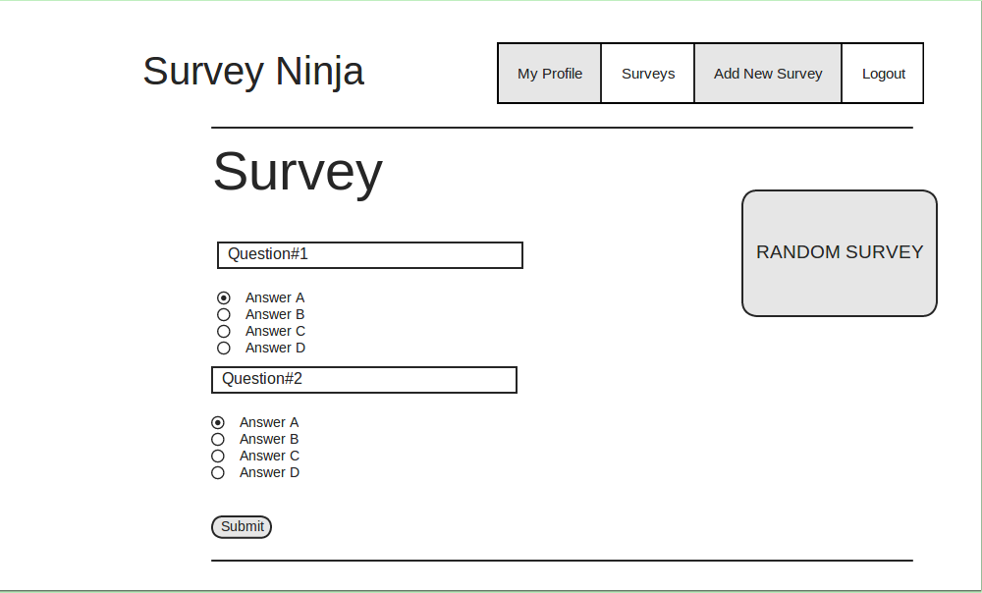

# Screenshots

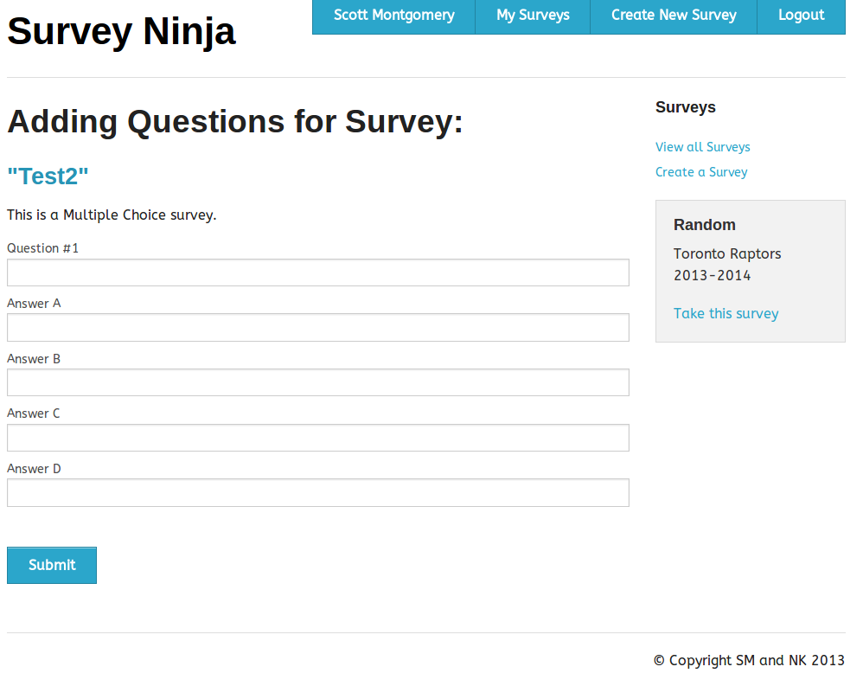

Figure Add Question Page

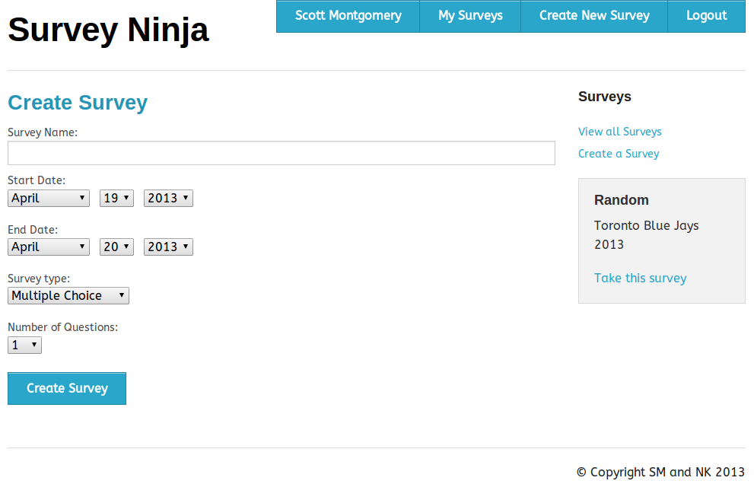

Figure Create Survey Page

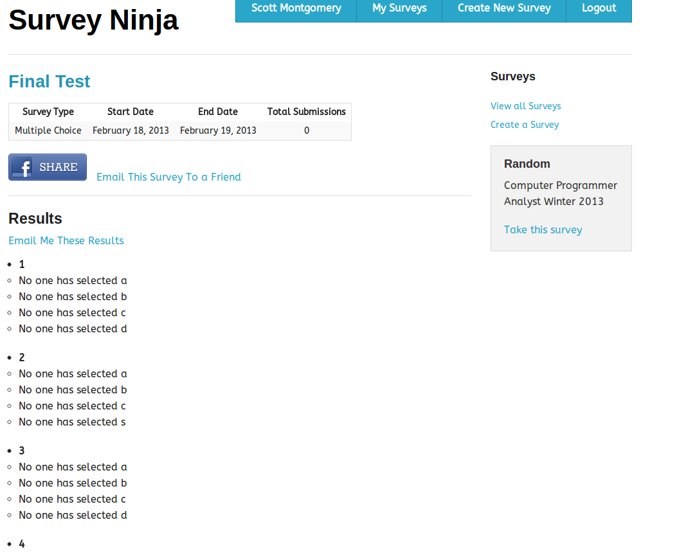

Figure Survey Details Page

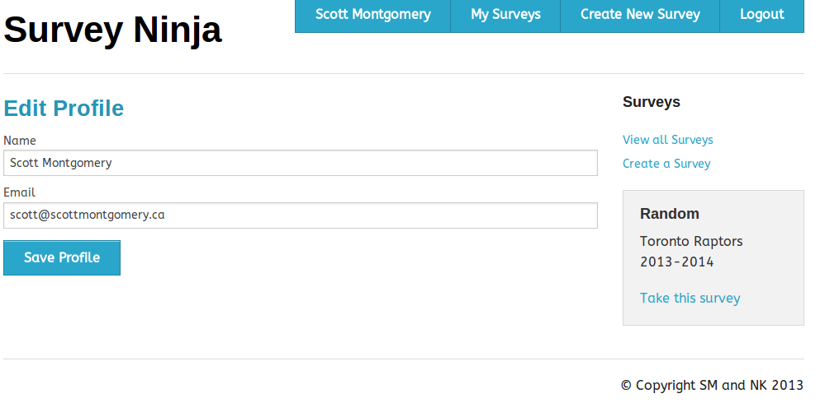

Figure Edit Profile Page

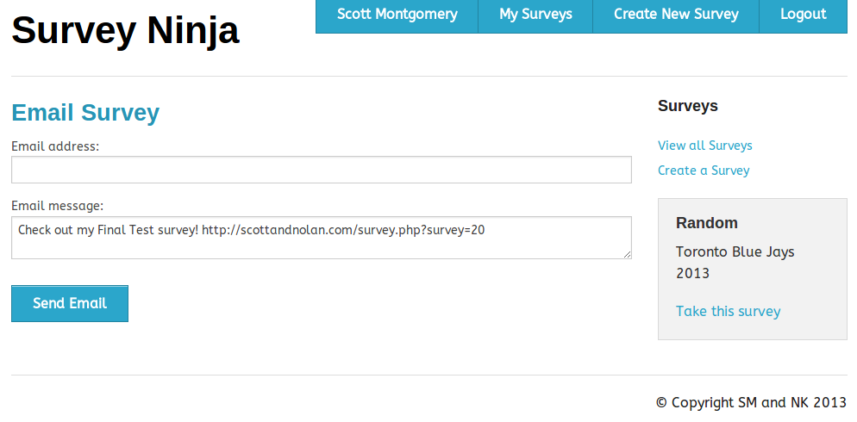

Figure Email Survey Link Page

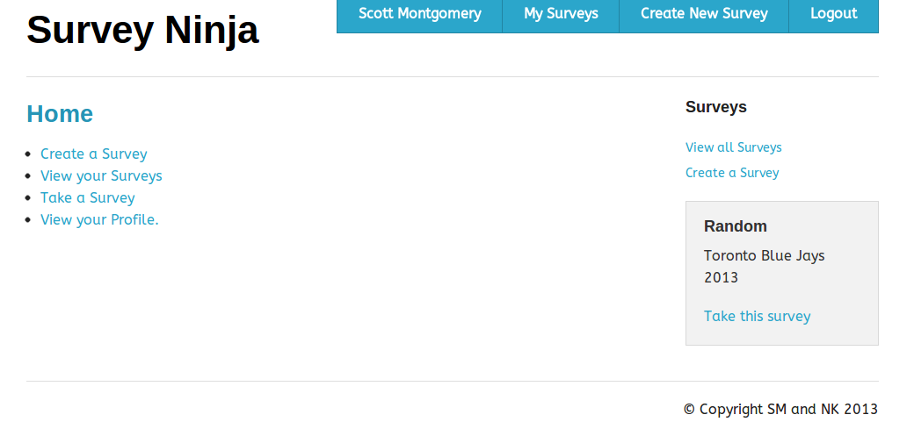

Figure Home Page

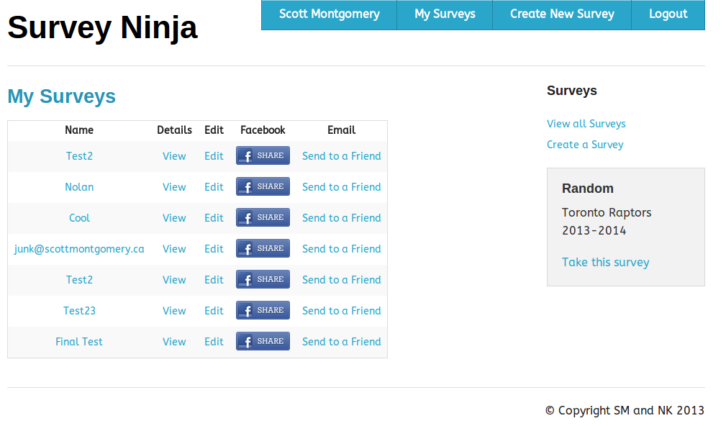

Figure My Surveys Page

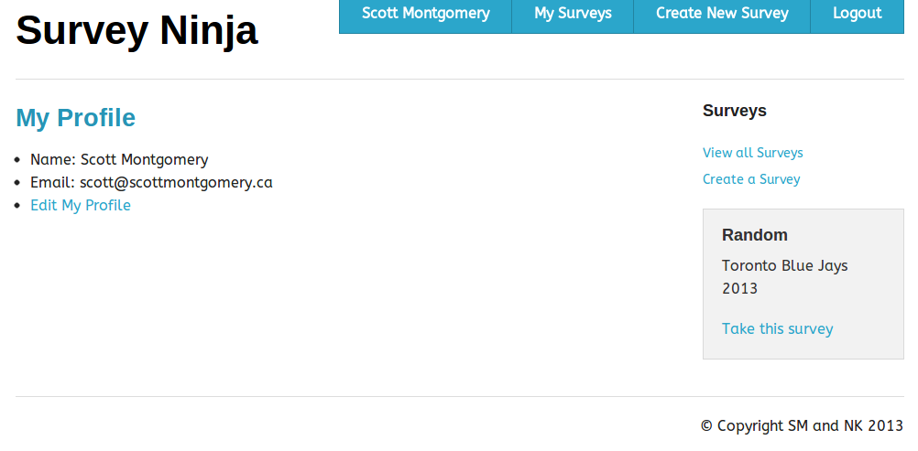

Figure My Profile Page

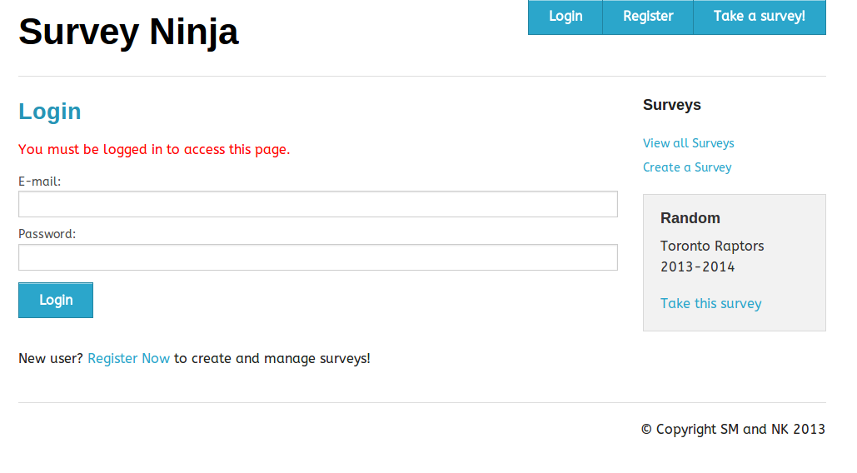

Figure Login Page

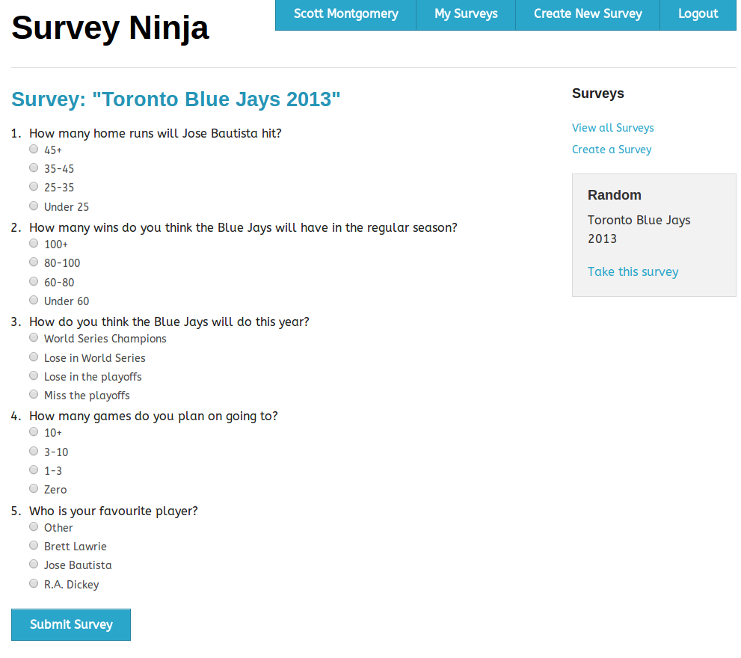

Figure Take Survey Page

# Future Functionality

* Private/public surveys, requiring login for certain surveys.
* Facebook login integration
* Display a list of submissions for a survey and details such as: time they were submitted, ip address
* Ability to create surveys with a combination of both multiple choice questions and true or false questions
* Ability to export survey information to a graph.
* Ability to export the details of a survey to an excel spreadsheet
* Ability to give other users edit permissions on a created survey.
* Create option to add category to a survey (ie sports, video games), Surveys can then be sorted to be viewed by a specific category
* Add an option for the user to reset their password and have a link to change their password emailed to their associated email account